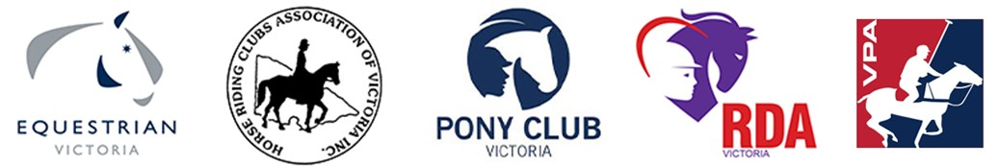

COVID UPDATE AS AT 29 SEPTEMBER 2020

Metropolitan Melbourne – Step 2
From 11:59 pm on 27 September 2020, metropolitan Melbourne moved to the Second Step towards COVID Normal.
The DHHS is currently updating their website, however, in summary, exercise is allowed within 5km of your home, or 5km from your workplace if you are on the permitted worker list (you must carry your permit).
- You can go riding within 5km of your home, but only where facilities are not required i.e. you can go for a trail ride within 5km of your home but you cannot go to your local club grounds. You must not travel more than 5km from where you live to exercise.
- You can also exercise within 5km of your workplace if you are a permitted worker, but you will have to carry your permitted worker permit.
- Exercise and outdoor social activity with members of your household or up to five people (including you, and from a maximum of two households) is permitted so long as you do not travel more than 5km. This must be in a public outdoor space and does not apply to people’s backyards or outdoor spaces connected to a home.
- You must limit your exercise to no more than two hours per day in total.
- Indoor facilities remain closed, unless you are a professional athlete, facility owner (where the facility is not open to the public) or are exempt under high performance guidelines (a permit is required)
- Restrictions related to exercising your horse on animal welfare grounds remain unchanged
- Coaching (in person) is still prohibited until such time as Metropolitan Melbourne reaches Step 3 restrictions.

Regional Victoria – Step 3
On 17 September, regional Victoria moved to the Third Step of the roadmap for reopening Victoria.
For sport and recreation in regional Victoria this includes:
- Indoor Facilities:
- Indoor facilities remain closed, unless you are a professional athlete, facility owner (where the facility is not open to the public) or are exempt under high performance guidelines (a permit is required).
- Outdoor physical recreation:
- Classes and training (coaching) can resume for up to ten people or a household - plus the trainer.
- You should keep 1.5 metres between yourself and others and make sure any equipment is cleaned between users.
- You must clean and disinfect equipment between users. Where possible you should minimise the sharing of equipment.
Return to Equestrian Sport
- The advice published on 24 September 2020 for Regional Victoria’s ‘Return to Equestrian Sport’ remains unchanged. Please follow the link below for further information
🔗 https://www.vic.equestrian.org.au/news/return-equestrian-competition-regional-victoria
