YVPC presents SIMON KEYTE POLO CLINIC
- Learn how to best prepare your horses for the new season
- Practice in the hitting cage
- BBQ lunch with polo talk from one of the world’s leading players
- SATURDAY 9th September 11.00am to 3.00pm
- At Simon Wincers beautiful property, Tarrawarra Road, Yarra Glen 3775
- $50 including BBQ (BYO drinks)
- Enquiries Sam Stott M 0402 148 995 E sam@linxfinance.com.au

- 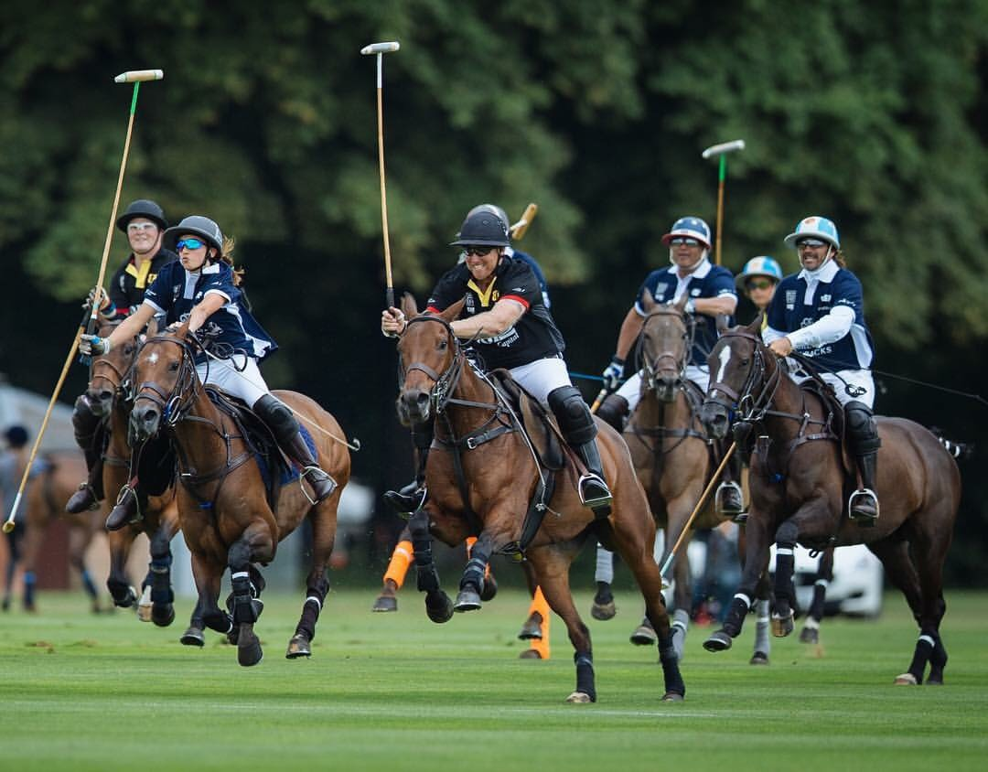

SIMON KEYTE 7 GOAL CHAMPION
- Born in New Zealand Simon has lived abroad for majority of his action-packed life.
- Polo Manager of Garangula (NSW) and Black Bears (England.)
- Played polo in over 25 counties including against Prince William, Prince Harry, Prince Charles, Adolfo Cambiaso (the world’s number 1 polo player, handicap 10 goals) and his relation Nina Clarkin. (The world’s number 1 female player with a handicap of 10 goals and relation of the Vestey’s of Coombe Farm)
- Winner of the Coronation cup playing for the Commonwealth in England.
- Simon’s knowledge from breeding, preparing, fixing and training is a study of its own.

